1st May 2026
Consultation on the proposed merger of Elements Diocesan Learning Trust (Elements) and Diocese of Worcester Multi Academy Trust (DoWMAT)
Dear Members, Directors, Local Academy/School Board Chairs and Governors
We hope you are well and would like to firstly take the opportunity to thank you for your continued support of our schools as we settle into the summer term. Further to the communication we shared in March, we wanted to provide an update on the exciting proposal to explore the proposed merger between Elements and DoWMAT.
As shared previously, we believe the possible merger presents a really positive opportunity for our schools, children and communities. As Diocese Trusts we are guided by the Church of England’s vision for education and believe the proposed merger strengthens our commitment to nurturing spiritual, moral, social, and academic development.
By increasing our collaboration and shared capabilities, we will be able to offer enhanced professional development opportunities to staff, through increased best practice and resource sharing and training, helping to retain and recruit high-quality staff. Similarly, we believe it will enhance our school improvement capability and will help us to drive further educational excellence in our classrooms, so we can deliver the very best possible education to our pupils.
We also believe this merger would provide improved operational efficiencies as regards procurement, finance, and administration and enhance financial and longer term sustainability for both Trusts.
As the views and feedback of our school communities are hugely important to us, we have been hard at work developing a consultation through which you can express your views about the proposed merger. We are eager to hear your thoughts and perspectives as part of this process. The consultation will run from Friday 1st May to Monday 1st June 2026, and full details and documentation are available on the Trust website at Diocese of Worcester Multi Academy Trust - Merge Consultation. We encourage you to read the documentation and respond to the consultation. We look forward to hearing your feedback particularly as regards governance.
To support this process, we will also be hosting several forums and meetings about this. These events will take place on the following dates and times and you are welcome to attend any of the following:
Staff Consultation Meetings | Public/Family Consultation Meetings
Elements
Tuesday 12th May St Mary’s School –15:30-16:30 | 17:00-18:00
Wednesday 13th May – Christ Church–15:30-16:30 | 17:00-18:00
Tuesday 19th May – Pedmore School –15:30-16:30 | 17:00-18:00
Wednesday 20th May – Church of the Ascension School –15:30-16:30 | 17:00-18:00
Thursday 21st May - Jesson’s School –15:30-16:30 | 17:00-18:00
DoWMAT Staff | Public/Family Consultation Meetings
St Barnabas CE School, Drakes Broughton  1st June 16:00-17:00 | St Barnabas CE School, Drakes Broughton  17:00-18:00
MS Teams – 15:30-16:30  11th May  (please request the MS Teams link via the email below) | MS Teams – 1800-19:00  11th May  (please request the MS Teams link via the email below)
Specific Governors Meetings
Local Academy Board Chairs DoWMAT | Tuesday 19th May 1800-19:00 MS Teams  (Members please request the MS Teams link via the email below)
Local School Board Chairs Elements | Tuesday 12th May 1800-19:00 St Mary’s School

We appreciate you may have questions and so we have therefore created an FAQ document via the website, to answer any immediate questions you have. You can also respond to the survey on the website. However, should you have any further questions please do attend one of the sessions or reach out directly so we can help.
Please contact mergerconsultation@dowmat.education. We are excited about the proposed merge and potential it will deliver for children, staff and the wider school community alike, and so we hope you too feel enthused about these plans. In the meantime, we wish you all another successful term and would like to thank you all for your ongoing support and collaboration as we explore this exciting opportunity.

Yours faithfully,

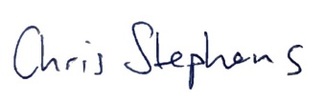
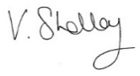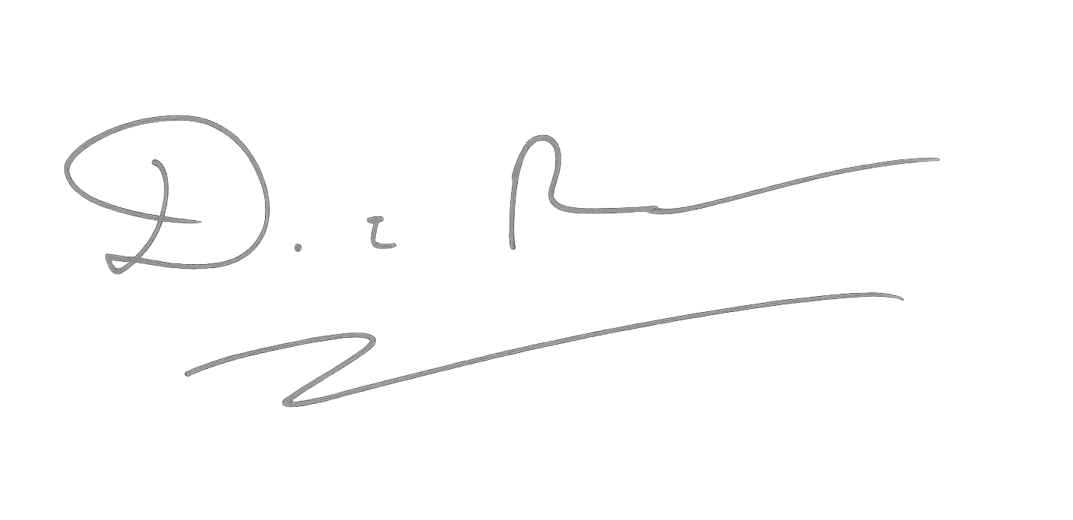
Vicki Shelley David Reeson Chris Stephens
Interim CEO Elements Elements Trust Board Chair DoWMAT Trust Board Chair
CEO DoWMAT

